**AWS Storage and Databases**

* Basic storage concepts
* Basic database concepts
* AWS Elastic Block Store (AWS EBS)
* AWS Simple Storage Service (AWS S3)
* AWS Elastic File System (AWS EFS)
* Storage solutions
* AWS Relational Database Service (AWS RDS)
* AWS DynamoDB
* AWS Redshift
* AWS Database Migration Service
* Additional database services

# AWS Instance Stores

## What are Instance Stores?

* Instance Store is a storage volume that acts as a physical hard drive.
* It provides temporary storage for [Amazon EC2 instance](https://www.w3schools.com/aws/aws_cloudessentials_ec2instancetypes.php).
* The data in an instance store persists during the lifetime of its instance.
* If an instance reboots, data in the instance store will persist.
* When the instance hibernates or terminates, you lose any data in the instance store.
* If an instance starts from a stopped state, it might start on another host where the used instance store does not exist.
* It is recommended to avoid storing valuable data in the store instance.
* Instance Stores are good for temporary files, and data that can be easily recreated.

## Example:

* AWS EC2 instance with an attached instance store is running.



* AWS EC2 instance is stopped or terminated.

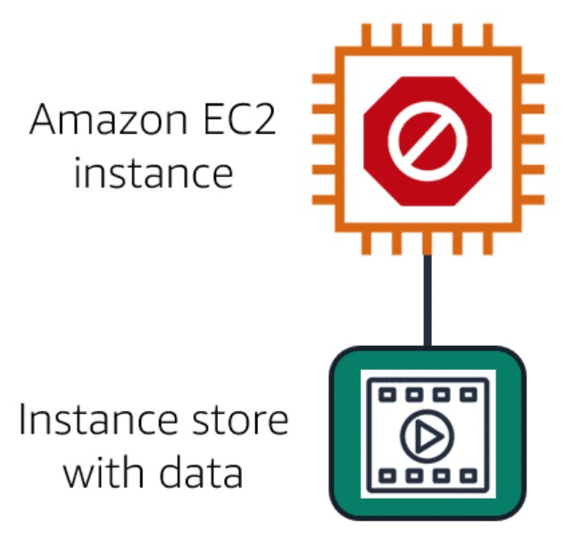

* All data on the attached instance store are deleted.

